**DIGITAL IMAGE PROCESSING**

**NUMBER PLATE RECOGNITION**

**Name: Pulugu yamini**

**Regno: 17MIS1123**

**Vit University Chennai Campus**

**WIN Semester – 2019-2020**

**TABLE OF CONTENTS:**

1. Abstract

2. Introduction – Details regarding basic concepts used in your project has to be described

3. Design / Architecture – System architecture to be drawn

4. Algorithms/Methods used – To be explained in detail with necessary diagram

5. List of Modules in the project

6. Description about each module – Detailed description and algorithm used in the module with appropriate low level design diagrams

7. Results and discussions

8. Conclusion

9. – Sample coding

10. – Results screen shot

**Abstract:**

Automatic Number Plate Recognition (ANPR) is an image processing technology which uses number (license) plate to identify the vehicle. The objective is to design an efficient automatic authorized vehicle identification system by using the vehicle number plate. The system is implemented on the entrance for security control of a highly restricted area like military zones or area around top government offices or in tollbooths. The developed system first detects the vehicle and then captures the vehicle image. Vehicle number plate region is extracted using the image segmentation in an image. Optical character recognition technique is used for the character recognition. The resulting data is then used to compare with the records on a database so as to come up with the specific information like the vehicle’s owner, place of registration, address, etc. The system is implemented and simulated in Matlab, and it performance is tested on real image. It is observed from the experiment that the developed system successfully detects and recognize the vehicle number plate on real images.

**Introduction**

Tollbooths in India generally employ a purely visual system of vehicle classification. However this causes a huge loss of revenue to the firms operating the tollbooths due to rampant malpractices and discrepancies. To keep a tab on the operators some tollbooths employ a system using fibre optic sensors to automatically classify a vehicle in the background and tally the results with the manual entries. However this system is expensive complicated and requires high maintenance. We aim to study the various systems that can be used to replace such a system with a cheaper and efficient alternative

License Plate recognition is one of the techniques used for vehicle identification purposes. The sole intention of this project is to find the most efficient way to recognize the registration information from the digital image (obtained from the camera). This process usually comprises of three steps. First step is the license plate localization, regardless of the license-plate size and orientation. The second step is the segmentation of the characters and last step is the recognition of the characters from the license plate. Thus, this project uncovers the fundamental idea of various algorithms required to accomplish character recognition from the license plate during Template Matching.

This feature of the algorithm mentioned above helped in achieving faster character recognition of the license plate. This process of character recognition consists of steps like Image processing, Defragmentation, Resizing and Character localization that are required to be performed on the image in order for Template Matching to be done.

**Design / Architecture – System architecture**

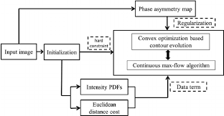

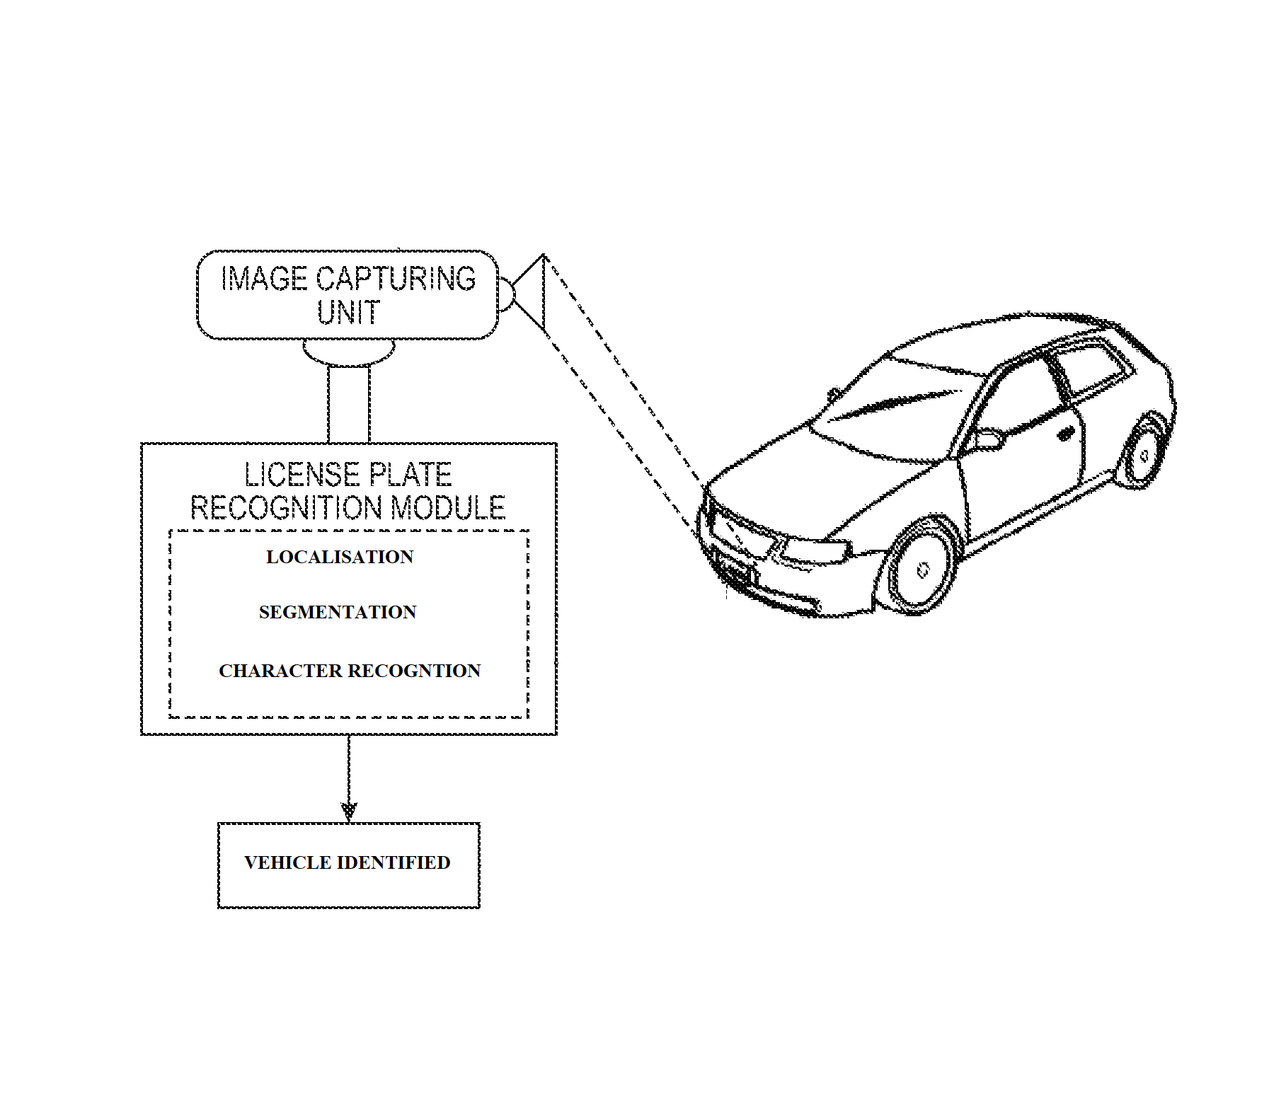

1. **Algorithms/Methods used**

**4.1) Algorithm for System:**

* Input image from camera
* Detect the number plate area
* Convert into greyscale image
* Convert to binary image
* Segmentation
* Character recognition

**Input image from camera**

* Capture image
* Store the image into a file format

**Detect the number plate area**

* Fill small holes including numbers of Number plate so that number plate area will be large to isolate from figure.
* Determine width and height of the image.
* Scan each pixel of line counting number of white pixels in the following system.
* Use the step no. 3 for both horizontal and vertical direction.
* Check number of possible areas.
* Logically AND with binary image obtained at “Convert image into binary”  
  algorithm.
* Crop the required area.

**Convert image into binary**

* Identify the intensity of the image
* Convert image to greyscale
* Calculate appropriate threshold value for the image
* Convert the image into binary image using the threshold

**Segmentation**  
 Filter the noise level present in the image.  
 Clip the plate area in such a way that only numbers of plate area extracted.  
 Separate each character from the plate.  
 **Character Recognition**

* Create the template file from the stored template images.
* Resize image obtained from segmentation to the size of template.
* Compare each character with the templates.
* Store the best matched character.

1. **List of Modules in the project**

* Localization

Locating number plate on the image.

* Character Segmentation

Locates the alpha numeric characters on a license plate.

* Optical Character Recognition (OCR)

Translates the segmented characters into text entries

1. **Description about each module**

**LOCALIZATION**

As input variable is an image I in color, whose size and resolution depending on the hardware used for acquisition. In order to process any image without a high computational cost we resize the image to 480 * 640 pixels. We convert the image to gray scale and binary values to carry out the localization process, which is based on extracting the characteristics of the elements of the picture (regional descriptors) to modify them according to whether they fulfill certain conditions depending on case is being valued and go refining the image with morphological operations. After applying the necessary changes and select the most favorable candidate, we extract it from the input image with the name 'ImgPlate' and display it on screen. Particularly noteworthy is the case in which the final image has a greater height (65 pixels) or less (25 pixels) that standard measures of plate after this localization process. In this case I opted for a different mask to filter the image, whose function is to delete the background, i.e. modify the capture area.

**SEGMENTATION**

The input variable is the output from Location Plate corresponding to the image of the gray‐scale plate (only plate), and returns the number of characters 'Objects', and a matrix images size [100 100 N] that contains the sub pictures of the characters found for subsequent recognition. The procedure can be summarized in five stages: Apply the method of Otsu to work with a binary image. This procedure selects the optimal level for thresholding depending on the intensity levels of each image. Eliminate the inclination of the binary image using features of higher object found in the image. I note this orientation and I apply rotation with this angle in the full picture. Remove impurities larger and smaller than the measurements of a character through the characteristics of each region and morphological operations until there are only eight objects (maximum characters in a plate). Divide those characters that are together because of previous operations or conditions of the image and original registration. In this loop must be especially careful because dividing the object, the number of them grows, which must be extended 'ImgChar' (100 * 100 * N) in the right place to show and recognize the characters in order and not to alter the sequence of registration. Finally, remove impurities that were created by segmenting characters, not to return to the next function an array of erroneous images.

**OPTICAL CHARACTER RECOGNTION**

OCR (optical character recognition) is the recognition of printed or written [text](http://whatis.techtarget.com/definition/text) [character](http://searchcio-midmarket.techtarget.com/definition/character)s by a computer. This involves photo scanning of the text character-by-character, analysis of the scanned-in image, and then translation of the character image into character codes, such as ASCII, commonly used in data processing.  OCR looks at each line of the image and attempts to determine if the black and white dots represent a particular letter or number. OCR was actually developed originally to assist sight-impaired individuals gain access to printed information. That same technology has been updated and improved and is now used to "read" computer files.OCR technology has been applied throughout the entire spectrum of industries, revolutionizing the document management process. OCR has enabled scanned documents to become more than just image files, turning into fully searchable documents with text content that is recognized by computers. With the help of OCR, people no longer need to manually retype important documents when entering them into electronic databases. Instead, OCR extracts relevant information and enters it automatically. The result is accurate, efficient information processing in less time.

**7.       Results and discussions**

This section presents the simulation results of the developed ANPR system. Firstly, the camera is interfaced using Matlab with the PC. The camera is attached using USB port. Different images of cars having different colors and structure types are taken and stored in PC. The different effects of the day lights are also considered during the processing.. After capturing the image the next step was the yellow search algorithm. The white region represents the yellow or color closer to the yellow. It can be observed that the yellow search algorithm successfully detect the ROI that only contain vehicle number plate. The smearing algorithm used next to extract the vehicle number plate. Once the vehicle number plate is extracted, it is converted into the binary format. The row and column segmentations methods are used next to extract the individual character in the vehicle number plate. Finally OCR is used for character recognition and each and every alphanumeric character is recognized.

The distance affects the size of the number plate in an image. Once the vehicle number plate is detected, the individual characters are recognized using the OCR algorithm. The OCR use correlation method for the character recognition and the probability of the recognition can also be calculated. The system is computationally inexpensive and can also be implemented for real time vehicle identification system.

**8.       Conclusion**

The automatic vehicle identification system using vehicle license plate is presented. The system use series of image processing techniques for identifying the vehicle from the database stored in the PC. The system is implemented in Matlab and it performance is tested on real images. The simulation results shows that the system robustly detect and recognize the vehicle using license plate against different lightening conditions and can be implemented on the entrance of a highly restricted areas. The implementation works quite well however, there is still room for improvement. The camera used in this project is sensitive to vibration and fast changing targets due to the long shutter time. The system robustness and speed can be increase if high resolution camera is used. The OCR methods used in this project for the recognition is sensitive to misalignment and to different sizes, the affine transformation can be used to improve the OCR recognition from different size and angles. The statistical analysis can also be used to define the probability of detection and recognition of the vehicle number plate.

**9.**

**– Sample coding**

imagen=imread('D:\images working\b.jpg');

figure(1)

imshow(imagen);

title('INPUT IMAGE WITH NOISE')

%% Convert to gray scale

if size(imagen,3)==3 % RGB image

imagen=rgb2gray(imagen);

end

%% Convert to binary image

threshold = graythresh(imagen);

imagen =~im2bw(imagen,threshold);

%% Remove all object containing fewer than 30 pixels

imagen = bwareaopen(imagen,30);

pause(1)

%% Show image binary image

figure(2)

imshow(~imagen);

title('INPUT IMAGE WITHOUT NOISE')

%% Label connected components

[L Ne]=bwlabel(imagen);

%% Measure properties of image regions

propied=regionprops(L,'BoundingBox');

hold on

%% Plot Bounding Box

for n=1:size(propied,1)

rectangle('Position',propied(n).BoundingBox,'EdgeColor','g','LineWidth',2)

end

hold off

pause (1)

%% Objects extraction

figure

for n=1:Ne

[r,c] = find(L==n);

n1=imagen(min(r):max(r),min(c):max(c));

imshow(~n1);

figure

pause(0.5)

end

**– Results screen shots**

**ORIGINAL IMAGE:**

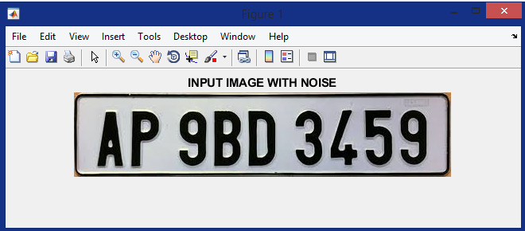

**THRESHOLD IMAGE:**

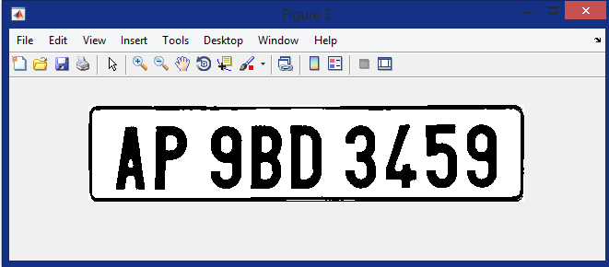

**SEGMENTATION:**

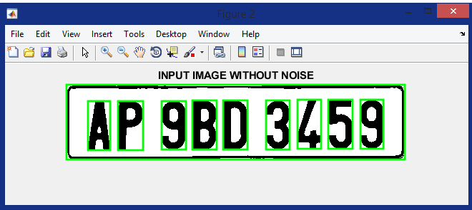

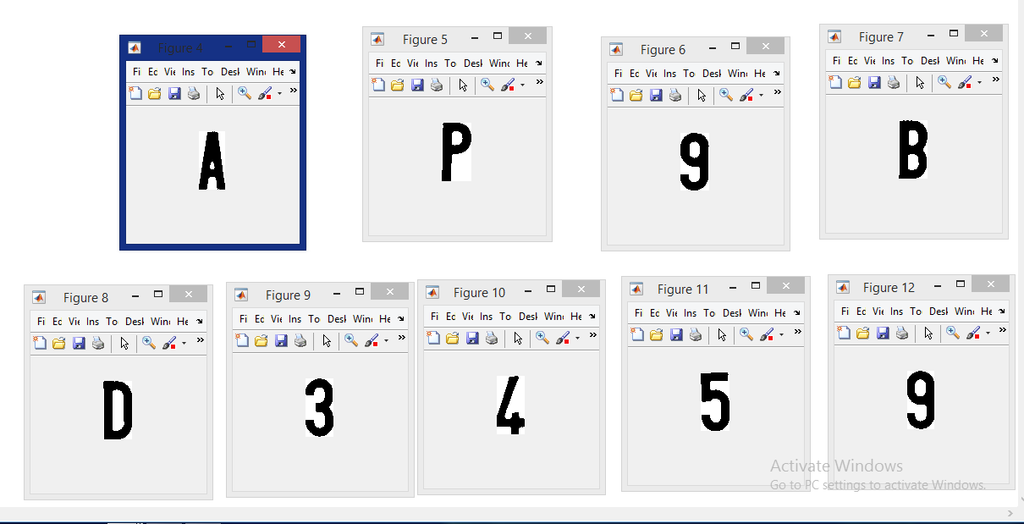

**CHARACTER RECOGNTION:**

